Title: Thermal tolerance and gene expression characterization in Manila clams (Ruditapes philippinarum), exposed to elevated carbon dioxide

Authors:

David C. Metzger, Carolyn S. Friedman, Emma B. Timmins-Schiffman and Steven B. Roberts*

*Corresponding author: e-mail: sr320@uw.edu; phone: 206-685-3742

Affiliations:

School of Aquatic and Fishery Sciences, University of Washington, 1122 NE Boat Street, Seattle, Washington, USA

Key Words:

Manila clam,ocean acidification, temperature, gene expression, environment, stress

Abstract

Global climate change, including ocean acidification, resulting from anthropogenic carbon dioxide (CO2) emissions poses a risk to the ecological landscape of intertidal and shallow subtidal communities. Organisms that inhabit these waters will have to cope with changing environmental conditions, particularly increases in partial pressure CO2 (pCO2) and in temperatures, through the appropriate modulation of physiological processes. The ability of a species to maintain homeostasis under changing environmental conditions will confer tolerance to organisms when faced with environmental change. In this study, juvenile Manila clams were exposed to elevated pCO2 conditions for 3 weeks and physiological impacts were assed by characterizing gene expression levels and evaluating thermal tolerance. Elevated pCO2 conditions did not significantly influence expression of candidate genes involved in thermal stress, protein translation, or oxidative stress. Exposure to elevated pCO2 did not significantly affect mortality of juvenile clams after an acute heat shock. These data suggest that Manila clams are capable of tolerating some environmental stressors associated with global climate change.

Introduction

Atmospheric carbon dioxide (CO2) levels have increased from 280 parts per million (ppm) prior to the industrial revolution to present day levels of 400 ppm, higher than they have been in the past 800,000 years (Lüthi et al. 2008). Atmospheric CO2 concentrations have fluctuated historically (Tyrrell, 2008), but current atmospheric CO2 concentrations are increasing at an unprecedented rate of 0.5% per year (Caldeira and Wickett, 2003; Orr et al. 2005). Increasing atmospheric levels of CO2 are expected to increase global temperatures by 2 to 5°C (Houghton et al. 2001) and impact the carbonate chemistry of seawater (Feely et al. 2004, 2008).

Oceans have absorbed roughly one third of the anthropogenic CO2 emissions (Sabine et al. 2004) so that the partial pressure of CO2 (pCO2) in the oceans is correlated to that in the atmosphere. When carbon dioxide from the atmosphere equilibrates with surface water of the oceans it reacts with water to form hydrogen and bicarbonate ions (Feely et al. 2004; Orr et al. 2005). This equilibrium reaction increases the oceanic concentration of bicarbonate and decreases the amount of carbonate available to calcifying organisms while also increasing the concentration of free hydrogen ions, causing the water to become more acidic (Zeebe and Wolf-Gladrow, 2001). If the current rate of fossil fuel emissions continues, atmospheric levels of CO2 will reach 750-1000 ppm by 2100, corresponding to a pH decrease of 0.3-0.5 units in the oceans, a process known as “ocean acidification” (Intergovernmental Panel on Climate Change 2007; Zeebe and Wolf-Gladrow 2001, Caldeira and Wickett 2005).

Organisms that inhabit intertidal and shallow subtidal waters are thought to be at risk from ocean acidification, particularly those dependent on carbonate-based structures for stability, defense, and survival (Fabry et al. 2008; Cooley and Doney, 2009). Temperature fluctuations associated with increased CO2 emissions (the greenhouse effect) are also predicted to impact near shore communities as temperature changes more rapidly in these shallower waters (Levitus et al, 2000; Nixon et al. 2004). Elevated pCO2 could cause a shift in physiological limitations as an organism is faced with another stressor, such as increased temperature. Changes in an organism’s ability to cope with environmental stress will in turn provide insight into potential changes to the ecological landscape of coastal communities.

One species that is susceptible to changes in environmental conditions is the Manila clam, Ruditapes philippinarum. The Manila clam is indigenous to the Philippines, South China and East China Seas, up to the Sea of Okhotsk and the southern Kuril Islands (Scarlato, 1981). Since being introduced to the west coast of the United States in the 1930’s (Magoon and Vining, 1981), they have become an economically important aquaculture species (Dumbauld et al. 2009). Manila clams are tolerant of a wide range of temperatures and salinities (Numaguchi 1998), however, little is known concerning their tolerance to ocean acidification.

The objective of this study is to examine the impact of elevated pCO2 on juvenile Manila clam physiology. Expression level of candidate genes involved in calcification, translation, stress response, and oxidative stress were measured during a three-week exposure to elevated pCO2 conditions. In addition, the minimum lethal temperature (MLT) for juvenile Manila clams was determined and the effect of elevated pCO2 conditions on juvenile Manila clam thermal limits assessed. Our hypothesis was that ocean acidification would negatively impact other stress-related physiological processes, so that exposure to a heat shock would result in higher mortality in clams exposed to elevated pCO2 compared to ambient pCO2 conditions.

Materials and Methods

Experimental design

Juvenile Manila clams (mean±SD; length =13.9mm±2.1; width=18.3mm±2.7; wet weight = 1.45g±0.6) were obtained from the Taylor Shellfish hatchery in Quilcene, WA and transported to the ocean acidification facility at the University of Washington Friday Harbor Laboratories on San Juan Island, WA. Clams were exposed to seawater equilibrated to ambient (400 μatm; pH 8.03) or elevated (1000 μatm; pH 7.67) pCO2. Gas equilibration was achieved by stripping seawater filtered to 0.2 µm of CO2 using a membrane contactor under vacuum pressure. Pure CO2 gas was then mixed with CO2-free air using gas proportionators. The prepared gas mixtures were then equilibrated with seawater using solenoid valves attached to Venturi injectors. Treatments were monitored by measuring pH using a Honeywell controller connected to a Durafet pH probe adjusted to maintain the desired pH. Durafet calibration was ensured daily using spectrophotometric pH. Total alkalinity (AT) measurements were performed prior to the addition of animals to the system and once per week following the addition of animals. The water chemistry inside the animal chambers (AT and spectrophotometric pH) were also monitored once a week. Carbonate chemistry measurements, including partial pressure CO2 as well as aragonite and calcite saturation, were calculated from AT, spectrophotometric pH, and salinity using the CO2 calculator “CO2Calc” and adjusting for ambient temperature of the experiment (13°C)(Robbins et al. 2010) with the following parameters: CO2 constants: Lueker et al. 2000, KHSO4: Dickson (1990b), pH Scale: Total scale (mol/kgSW), Air-Sea Flux: Wanninkhof, 1992.

Each experimental treatment contained 8 replicate 3-L chambers maintained at a constant temperature of 13°C and a flow rate of 1.9L/hr. Each chamber contained 10 clams for a total starting number of 80 juvenile clams for each treatment. At the end of each week, one clam from each chamber was sacrificed and gill tissue dissected and flash frozen in liquid nitrogen. A total of eight clams were sampled from each pCO2 treatment each week leaving a total of 56 clams at the end of the three-week sampling period. After the three weeks the remaining clams were exposed to a temperature stress. You need to say something here about finding the lethal heat treatment.

Clams were transferred to a temperature-equilibrated treatment water bath and exposed for one hour to 38 or 39°C. During thermal treatments, clams were completely submerged in their designated pCO2 treatment seawater. Clams were then returned to 13°C at their respective pCO2 treatment conditions and mortality was monitored for one week. A total of 14 clams (two replicate groups of seven animals) were used for each pCO2 and temperature combination. Mortality was assessed based on gaping behavior. Clams that failed to close their shells in response to mechanical stimulation were considered moribund.

RNA extraction and cDNA synthesis

RNA was extracted from gill tissue using TriReagent (Molecular Research Center, Cincinnati, OH, USA) following the manufacturer’s recommended protocol. Total RNA was DNase treated (DNA Free kit; Ambion, Austin, TX, USA) following the manufacturer’s rigorous protocol to remove potential DNA carryover from RNA extractions. Purified RNA was quantified using a Nanodrop ND-1000 UV-Vis spectrophotometer (NanoDrop Technologies Inc., Rockland, DE). Reverse transcription reactions were conducted using M-MLV reverse transcriptase (Promega, Madison, Wisconsin) and 0.5ug of total RNA to generate complementary DNA (cDNA).

Quantitative PCR analysis

Primers for quantitative PCR (qPCR) analysis were generated using Primer3 software (Rozen and Skaletsky, 2000) from sequences provided in the Manila clam transcriptome database (RuphiBase, http://compgen.bio.unipd.it/ruphibase). Primer sequences are provided in Table 2. All primers were ordered from IDT (Coralville, IA, USA). Quantitative PCR reactions were carried out in 20 ul reaction volumes consisting of 1x Ssofast EvaGreen Supermix (Bio-Rad, Hercules, CA), 0.2 µM of each primer, and 2 ul of diluted (1:5) cDNA. Amplification reactions were carried out using a CFX96 Real-Time PCR Detection System (Bio-Rad, Hercules, CA) with the following cycling parameters: 98°C 2min, followed by 40 cycles of 98°C for 2sec, 60°C for 5sec. Melt curve analysis was performed after cycle 40 by increasing the annealing temperature from 65°C to 95°C in 0.2°C increments and measuring fluorescence at each increment. All samples were run in duplicate. Efficiencies of qPCR reactions were calculated using PCR miner software (Zhao and Fernald, 2005). Expression values were calculated using the following equation: 1/(1+Efficiency)Ct . Calculated expression values were then normalized to elongation factor-1 alpha (ef-1α). Ef-1α is a commonly used normalizing gene and has previously been used as a reference gene in similar experiments (O’Donnell et al. 2009). The stability of ef-1 α was confirmed for this by a two-way ANOVA analysis, which showed no significant difference in ef-1α expression between ambient and elevated pCO2 treatments.

Statistical Analysis

Prior to statistical analysis, normalized expression values (NEV) were transformed by taking the natural log of one plus the normalized expression value [ln(NEV+1)]. Two outliers were identified in the expression data from week 1 and week 2 in the elevated pCO2 treatment for all qPCR assays and were omitted from further analysis resulting in an n=7 for the indicated sampling groups. A two-way ANOVA was conducted on the transformed expression data to test for significant effects of treatment and time. A Kaplan-Meier survivorship analysis was applied to survival data from the thermal stress trial and significance was determined using a log-rank test. Significance was determined based on α=0.05. All statistical analysis was conducted using SPSS statistical software (IBM, Somers, NY).

Results/Discussion

Elevated pCO2 treatment

Partial pressure CO2 conditions were maintained at two different levels for the duration of the experiment (Figure 1A). Conditions representing present day (ambient) pCO2 concentrations were maintained at 424±45μatm (mean±SD) corresponding to a pH of 8.01±0.04. Elevated levels of pCO2 were maintained at 1146±312μatm corresponding to a pH 7.63±0.10 (Figure 1), which are within the projected changes expected to occur by 2100 (Caldeira and Wickett 2003). The greatest amount of variability was observed in samples taken during week 2 in which a spike in pCO2 was observed in the elevated treatment (Figure 1). No mortalities occurred as a result of the different CO2 treatment conditions. A summary of results from the carbonate chemistry sampling is provided in Table 3.

Gene expression analysis

One of the most commonly studied processes in organisms facing elevated pCO2 conditions is calcification. Most reports to date have documented a negative effect of elevated pCO2 conditions on calcifying organisms (Kroeker et al. 2010; Gazeau et al. 2007; Orr et al. 2005). The gene encoding perlucin 6, a calcium carbonate nucleation factor (Weiss et al. 2000; Blank et al. 2003), was recently identified in larval Manila clams (Metzger et al. in review). Perlucin 6 is a C-type lectin (Mann et al, 2000) that has been shown to facilitate the formation calcium carbonate structures (Blank et al. 2003) and may therefore be an important component of calcification in Manila clams.

In order to maintain normal growth, or minimally prevent reduced shell mass or reduced shell integrity under corrosive high pCO2 conditions, altered expression of genes associated with calcification and shell growth would be expected. Perlucin 6 transcript levels were not significantly different in gill tissue of juvenile clams exposed to elevated pCO2 (Figure 2A). This result suggests that the pCO2 conditions used in this study do not significantly affect the processes of shell deposition in juvenile Manila clams.

Juvenile Manila clams are sedentary infaunal organisms that lived buried in sediment where pCO2 is typically higher than that of the surrounding water. Therefore, Manila clams could be adapted to the elevated pCO2 conditions used in this experiment. Alternatively, it is possible that perculin activity is altered, but only in specific tissues. For instance, expression of genes involved in bio mineralization has been shown to vary between tissues in other calcifying organisms (Hüning et al. 2012).

Ion transport is necessary for maintaining ion homeostasis, particularly in gill tissue. Calmodulin is a Ca2+ dependent messenger protein that moderates the activity of enzymes involved in several vital cellular processes, including ATPase driven ion pumps (Klee 1980). Calmodulin transcripts in corals decreased under elevated pCO2 conditions (Kaniewska et al. 2012). There was no effect of elevated pCO2 on calmodulin transcript levels in juvenile Manila clams (Figure 2B), suggesting that ion homeostasis in the gills may not be impacted under the experimental conditions.

Increased expression of genes associated with protein translation and proteolysis can occur during periods of increased metabolic demand as an means to provide alternative energy sources through the break down of amino acids (Hawkins and Day 1996). Previous studies have identified changes in protein concentration of larval barnacles (Wong et al 2011) exposed to elevated pCO2. Cathepsin and elongation factor (EF) proteins are involved in mediating protein synthesis and degradation. Elevated pCO2 conditions did not influence cathepsin L or EF2 transcript levels in juvenile clam gill tissue (Figure 2C). These results could indicate that juvenile Manila clams possess adequate energetic resources via routine metabolic activity to compensate for the additional stress of an elevated pCO2 environment.

Heat shock proteins (hsp) are involved in several physiological processes including protein metabolism, response to thermal stress, immune response, and apoptosis (e.g. Feder and Hofmann, 1999; Roberts et al. 2010). HSPs are molecular chaperones that bind and stabilize proteins, aiding in protein synthesis or the repairing of damaged proteins from processes such as oxidative stressed. Hsp90 is a ubiquitously expressed protein that undergoes an ATPase-dependent conformational change upon activation (Pearl and Prodromou 2006). Conditioning of the hsp stress response has been shown for several environmental conditions (Bierkens 2000). Expression of hsp90 has also been shown to decrease with age in the hard clam Mercenaria mercenaria (Farcy et al. 2007). Age dependent regulation of hsp90 might suggest that it is regulated during early larval periods while juvenile and adults do not actively express hsp90 to the same degree.

Analysis of hsp90 expression in gill tissue of juvenile clams exposed to elevated pCO2 conditions was not significantly different from those compared to ambient pCO2 conditions (Figure 2E). It is possible that hsp90 is not required to cope with this particular stress response, or that regulation of hsp90 does not occur at the transcriptional level.

Elevated pCO2 conditions can also invoke an oxidative stress response (Tomanek et al. 2011). Oxidative stress is caused by the production of reactive oxygen species (ROS). Antioxidant defense is a primary response of Eastern oysters exposed to elevated pCO2 conditions (Tomanek et al. 2011). Glutatione peroxidase 3 (GPx3) catabolizes ROS to more benign compounds. In this study, elevated pCO2 conditions did not impact the expression of GPx3 transcripts (Figure 2F) suggesting that juvenile Manila clams are not experiencing increased levels of oxidative stress as a result of elevated pCO2 conditions. Variability between species’ oxidative stress response may be an important component regarding their tolerance to elevated pCO2 conditions, however a side-by-side comparison of species is needed before conclusions regarding species specific oxidative stress response regulation can be determined.  
I think you should have a concluding paragraph for the gene expression part and bring it all together. You didn’t see any differences in expression, but this could be because of x, y , and z.

Thermal tolerance

Juvenile Manila clams held in ambient or elevated pCO2 seawater for three weeks were heat shocked to assess the influence of elevated pCO2 conditions on thermal tolerance (Figure 3).

No differences in survival, OM, or MDD were observed at 39°C (the pre-determined minimum lethal temperature) or 38°C heat shock (p>0.05). The OM in animals heat shocked at 39°C occurred on day 3 in both the ambient and elevated pCO2 treatment with a mean day of death for animals exposed to 39°C of 4.1 DPT for animals treated with ambient pCO2 seawater while the elevated pCO2 treatment was slightly lower at 3.8 DPT. The OM at 38°C occurred on day 4 in both the ambient and elevated pCO2 treatments. The MDD for animals heat shocked at 38°C was 6.6 and 6.7 for ambient and elevated pCO2 treated animals respectively with 64.3% surviving until day 7 in the ambient pCO2 group and 71.4% surviving in the elevated pCO2 treatment.

Global climate change’s associated effects, such as ocean acidification and increasing sea surface temperatures, will occur in concert with other naturally occurring environmental stressors. Some of these naturally occurring stressors may be benign under normal environmental conditions, but could become stressful or lethal when an organism is faced with a novel, sustained stressor. Concurrent changes in temperature and carbonate chemistry can have additive, synergistic, or antagonistic effects on physiological processes (Folt et al. 1999; Darling and Cote 2008; Hofmann and Todgham 2010). Intertidal and shallow subtidal species may already be functioning close to their physiological limits and thus may be more susceptible to changing environmental conditions as a result of climate change (Tomanek 2008; Somero 2010; Peck et al. 2009, 2010; Christensen et al. 2011).

Alternatively, organisms inhabiting these highly dynamic ecosystems may be more adapted to harsh conditions. Depending on the species and developmental period, the effects of combined stressors can vary (Pörtner 2008). For example, antagonistic effects of combined thermal and elevated pCO2 conditions were observed in the tropical sea urchin, Tripneustes gratilla, where elevated pCO2 conditions reduced calcification and nullified the positive growth impact of warmer temperatures (Brennand et al. 2010). Combined high pCO2 and thermal treatments increased mortality of larval red abalone, Haliotis rufenscens, compared to either treatment alone (Zippay and Hofman 2010). A multispecies study among bivalves showed a variable effect of elevated pCO2 and warmer temperatures on growth and survival of larval and juvenile eastern oysters, Crassostrea virginica, hard clams Mercenaria mercenaria, and bay scallops, Argopecten irradians (Talmage and Gobler 2011). Variability among species may be due, in part, to differences in life history among species (Talmage and Gobler 2011). Similar to the results presented for juvenile Manila clams, mortality of juvenile *M. mercenaria* was unaffected by elevated temperatures suggesting a potential resistance of infaunal species to increased temperature and pCO2 conditions.

Conclusions

Ocean acidification conditions did not alter the response of manila clams to temperature stress. In addition, the expression of several genes associated with processes such as calcium ion binding, metabolism, translation, or stress response, were not different in juvenile clams exposed to elevated pCO2. While there is a need for additional studies that examine different life stages, these data indicate juvenile clams could be relatively more resilient to elevated pCO2 conditions expected to occur this century when compared with other aquatic invertebrates of the same life stage (xxxxxxxx). This resiliency is consistent with their life history as adults are infaunal and live buried in sediment where pCO2 is typically higher due to respiration and decomposition. Adaptation has been observed in other sub-benthic bivalves including the hard clam, Mercinaria mercenaria, where increased rates of calcification were attributed to high pCO2 conditions experience in sediment (Waldbusser et al. 2010). Further analysis of the mechanisms evoked by these organisms during metamorphosis into adults may provide insight into successful adaptation strategies to cope with the environmental conditions predicted to occur as a result of anthropogenic CO2 emissions and climate change.

Acknowledgements

The authors would like to Dr. Emily Carrington and Dr. Michael O’Donnell for letting us use their facility and their technical support. We would also like to thank Joth Davis and Taylor Shellfish Farms for supplying the juvenile clams. Funding for this research was provided by Washington Sea Grant and a National Oceanographic and Atmospheric Administrations Saltonstall-Kennedy Grant (# NA09NMF4270093**).**

References

Bakun A (1990) Global climate change and intensification of coastal ocean upwelling, Science, 247:198-201

Barton A, Hales B, Waldbusser GG, Langdon C, Feely RA (2012) The Pacific oyster Crassostrea gigas, shows negative correlation to naturally elevated carbon dioxide levels: Implications for near-term ocean acidification effects. Limnol Oceanogr 57: 698-710

Bierkens JGEA (2000) Applications and pitfalls of stress-proteins in biomonitoring. Toxicology 153:61-71

Blank S, Arnoldi M, Khoshnavaz S, Treccani L, Kuntz M, Mann K, Grathwohl G, Fritz M (2003) The nacre protein perlucin nucleates growth of calcium carbonate crystals. J Microscopy 212: 280-291

Brennand HS, Soars N, Dworjanyn SA, Davis AR, Byrne M (2010) Impact of ocean warming and ocean acidification on larval development and calcification in the sea urchin Tripneustes gratilla. PLoS One 5: e11372

Caldeira K, and Wickett ME (2003) Anthropogenic carbon and ocean pH. Nature 425: 365

Caldeira K and Wickett ME (2005) Ocean model predictions of chemistry changes from carbon dioxide emissions to the atmosphere and ocean. J Geophys Res 110: doi:10.1029/2004JC002671

Chapman RW, Mancia A, Beal M, Veloso A, Rathburn C, Blair A, Holland AF, Warr GW, Didinato G, Sokolova IM, Wirth EF, Duffy E, Sanger D (2011) The transcriptomic responses of the eastern oyster, Crassostrea virginica, to environmental conditions. Mol Ecol 20: 1431-1449

Christensen AB, Nguyen HD, Byrne M (2011) Thermotolerance and the effects of hypercapnia on the metabolic rate of the ophiuroid Ophionereis schayeri: inferences for survivorship in a changing ocean. J Exp Mar Biol Ecol, 403, 31-38

Cooley SR & Doney SC (2009) Anticipating ocean acidification’s economic consequences for commercial fisheries. Environ Res Lett 4:024007

Darling ES, Cote IM (2008) Quantifying the evidence for ecological synergies. Ecol Lett 11:1278-1286

Dickson AG (1990b) Thermodynamics of the dissociation of boric acid in synthetic seawater from 273.15 to 318.15 K: Deep Sea Res Part A 37:755–766

Dumbauld BR, Ruesink JL, Rumrill SS (2009) The ecological role of bivalve shellfish aquaculture in the estuarine environment: A review with application to oyster and clam culture in West Coast (USA) estuaries. Aquaculture 290:196-223

Elston RA, Hasegawa H, Humphrey KL, Polyak IK, Hase CC (2008) Re-emergence of Vibrio tubiashii in bivalve shellfish aquaculture: severity, environmental drivers, geographic extent and management. Dis Aquat Org 82:119-134

Fabry VJ, Seibel BA, Feely RA, and Orr JC (2008) Impacts of ocean acidification on

marine fauna and ecosystem processes. ICES J Mar Sci 65:414-432

Farcy E, Serpentini A, Fiévet B, Lebel JM (2007) Identification of CDNAs encoding HSP70 and HSP90 in the abalone Haliotis tuberculata: transcriptional induction in response to thermal stress in hemocyte primary culture. Comp Biochem Physiol 146:540-550

Feder ME & Hofmann GE (1999) Heat-shock proteins, molecular chaperones, and

the stress response: evolutionary and ecological physiology. Annu Rev Physiol 61:243-282

Feely RA, Sabine CL, Lee K, Berelson W, Kleypas J, Fabry VJ, Millero FJ (2004) Impact of anthropogenic CO2 on the CaCO3 system in the oceans. Science 305:362-366

Feely RA, Sabine CL, Hernandez-Ayon M, Ianson D, Hales B (2008) Evidence for

upwelling of corrosive “acidified” water onto the continental shelf. Science 320:1490-1492

Fehsenfeld S, Kiko R, Appelhans Y, Towle DW, Zimmer M, Melzner F (2011) Effects of elevated seawater pCO2 on gene expression patterns in the gills of the green crab, Carcinus maenas. BMC Genom 12:488

Findlay HS, Wood HL, Kendall MA, Spicer JI (2009) Calcification, a physiological process to be considered in the context of the whole organism. Biogeosciences Discuss 6:2267-2284

Folt CL, Chen CY, Moore MV, Burnaford J (1999) Synergism and antagonism among multiple stressors. Limnol 44:864-877

Gazeau F, Quiblier C, Jansen JM, Gattuso J-P, Middelburg JJ, Heip CHR (2007) Impact of elevated CO2 on shellfish calcification. Geophys Res Lett 34:L07603

Gracey AY (2007) Interpreting physiological responses to environmental change through gene expression profiling. J Exp Bio 209:1584-1592

Hawkins AJS and Day AJ (1996) The metabolic basis of genetic differences in growth and efficiency among marine animals. J Exp Mar Biol Ecol 203:93-115

Hofmann GE, Todgham AE (2010) Living in the now: physiological mechanisms to tolerate a rapidly changing environment. Annu Rev Physiol 72:127-145

Houghton JT, Albritton DL, Barker T, Bashmakov IA et al. (2001) Climate change 2001-the scientific basis: contribution of working group I to the third assessment report of the intergovernmental panel for climate change. Cambridge University Press, Cambridge

Hüning AK, Melzner F, Thomsen J, Gutowska MA, Krämer L, Frickenhaus S, Rosenstiel P, Pörtner H-O, Philipp EER, Lucassen M (2012) Impacts of seawater acidification on mantle gene expression patterns of the Baltic Sea blue mussel: implications for shell formation and energy metabolism. Mar Biol DOI 10.1007/s00227-012-1930-9

IPCC (Intergovernmental Panel on Climate Change) (2007) Climate change 2007 synthesis report, Cambridge University Press, New York

Kaniewska P, Campbell PR, Kline DI, Rodriguez-Lanetty M, Miller DJ, Dove S, Hoegh-Guldberg O (2012) Major cellular and physiological impacts of ocean acidification on a reef building coral. PLoS One 7:e34659

Klee CB, Crouch TH, Richman PG (1980) Calmodulin. Ann Rev Biochem 49:489-515

Kroeker KJ, Kordas RL, Crim RN, Singh GG (2010) Meta-analysis reveals negative yet variable effects of ocean acidification on marine organisms. Ecol Letters 13:1419–1434

Lachkar, Z and Gruber N (2012) Response of biological production and air-sea CO2 fluxes to upwelling intensification in the California and canary current systems. J Mar Sys doi: 10.1016/j.jmarsys.2012.04.003

Le Quesne WJF and Pinnegar JK (2011) The potential impacts of ocean acidification: scaling from physiology to fisheries. Fish Fisheries doi: 10.1111/j.1467-2979.2011.00423.x

Levitus S, Antonov JI, Boyer TP, Stephens C (2000) Warming of the world ocean. Science 287: 2225-2229

Liu W, Huang X, Lin J, He M (2012) Seawater acidification and elevated temperature affect gene expression patterns of the pearl oyster Pinctada fucata. PLoS One 3:e33679

López IR, Kalman J, Vale C, Blasco J (2010) Influence of sediment acidification on the bioaccumulation of metals in Ruditapes philippinarum. Environ Sci Pol Res 17: 1519-1528

Lueker TJ, Dickson AG, Keeling CD (2000) Ocean pCO2 calculated from dissolved inorganic carbon, alkalinity, and equations for K1 and K2—Validation based on laboratory measurements of CO2 in gas and seawater at equilibrium. Mar Chem 70:105–119

Lüthi D, Le Floch M, Bereiter B, Blunier T, Barnola J-M, Siegenthaler U, Raynaud D, Jouzel J, Fischer H, Kawamura K, and Stocker TF (2008) High-resolution carbon dioxide concentration record 650,000–800,000 years before present. Nature 453:379- 382

Magoon C and Vining R (1981) Introduction to shellfish aquaculture. Washington Dept. of Natural Resources, Seattle, 28 p

Mann K, Weiss IM, Andre S, Gabius H-J, Fritz M (2000) The amino acid sequence of the abalone (Haliotis laevigata) nacre protein perlucin. Detection of a functional C-type lectin domain with galactose/mannose specificity. Eur J Biochem 267:5257–5264

Moya A, Huisman L, Ball EE, Hayward DC, Grasso LC, Chua CM, Woo HN, Gattuso JP, Foret S, Miller DJ (2012) Whole transcriptome analysis of the coral Acropora millepora reveals complex responses to CO2-driven acidification during the initiation of calcification. Mol Ecol doi: 10.111/j.1365-294X.2012.05554.x

Metzger R, Sartoris FJ, Langenbuch M, Pörtner HO (2007) Influence of elevated CO2 concentrations on thermal tolerance of the edible crab Cancer pagurus. J Therm Biol 32:144-151

Nixon SX, Granger S, Buckley BA, Lamone M, Rowell B (2004) A one hundred and seventeen year coastal water temperature record from Woods Hole, Massachusetts. Estuaries 27: 397-404

Numaguchi K (1998) Preliminary experiments on the influence of water temperature, salinity and air exposure on the mortality of Manila clam larvae. Aquacult Int 6:77-81

O’Donnell M, Hammond L, Hofmann G (2009) Predicted impact of ocean acidification on a marine invertebrate: elevated CO2 alters response to thermal stress in sea urchin larvae. Mar Biol 156:439-446

O’Donnell MJ, Todgham AE, Sewell MA, Hammond LM, Ruggiero K, Fangue NA, Zippay ML, Hofmann GE (2010) Ocean acidification alters skeletogenesis and gene expression in larval sea urchins. Mar Ecol Prog Ser 398:157-171

Orr JC, Fabry VJ Aumont O, Bopp L, Doney SC, Feely RA, Gnanadesikan A, Gruber N, Ishida A, Joos F, Key RM, Lindsay K, Maier-Reimer E, Matear R, Monfray P, Mouchet A, Najjar RG, Plattner GK, Rodgers KB, Sabine CL, Sarmiento JL, Schlitzer R, Slater RD, Totterdell IJ, Weirig M-F, Yamanaka Y, Yool A (2005) Anthropogenic ocean acidification over the twenty-first century and its impact on calcifying organisms. Nature 437: 681–686

O’Donnell MJ, Todgham AE, Sewell MA, Hammond LM, Ruggiero K, Fangue NA, Zippay ML, Hofmann GE (2010) Ocean acidification alters skeletogenesis and gene expression in larval sea urchins. Mar Ecol Prog Ser 398:157-171

Pearl LH and Prodromou C (2006) Structure and mechanism of the hsp90 molecular chaperone machinery. Ann Rev Biochem 75:271-294

Peck LS, Massey A, Thorne MaS, Clark MS (2009) Lack of acclimation in Ophionotus victoriae: brittle stars are not fish. Polar Biol 32:399-402

Peck LS, Morley SA, Clark MS (2010) Poor acclimation capacities in Antarctic marine ectotherms. Mar Biol 157:2051-2059

Pörtner H (2008) Ecosystem effects of ocean acidification in times of ocean warming: a phsyiologist’s view. Mar Ecol Prog Ser 373:203-217

Robbins LL, Hansen ME, Kleypas JA, Meylan SC (2010) CO2calc—A user-friendly seawater carbon calculator for Windows, Max OS X, and iOS (iPhone): U.S. Geological Survey Open-File Report 2010–1280; 17

Roberts RJ, Aguis C, Saliba C, Bossier P, Sung YY (2010) Heat shock proteins

(chaperones) in fish and shellfish and their potential role in relation to fish health: a review. J Fish Dis 33:789-801

Rozen S & H. Skaletsky. 2000. Primer3 on the WWW for general users and for biologist programmers. In: Krawetz S, & S. Misener (eds) Bioinformatics Methods and Protocols: Methods in Molecular Biology. Humana Press, Totowa, NJ, 365-386

Sabine CL, Feely RA, Gruber N, Key RM, Bullister JL, Wanninkhof R, Wong CS, Wallace DWR, Tilbrook B, Millero, FJ, Peng T-H, Kozyr A, Ono T, Rios AF (2004) The ocean sink for CO2. Science 305:367-371

Scarlato OA (1981) Bivalves of temperate waters of the Northwestern part of the Pacific ocean. Nauka Press, Leningrad, 408

Somero GN (2010) The physiology of climate change: how potentials for acclimatization and genetic adaptation will determine ‘winners’ and ‘losers’. J Exp Biol 213:912-920

Talmage SC, Gobler CJ (2011) Effects of Elevated Temperature and Carbon Dioxide on the Growth and Survival of Larvae and Juveniles of Three Species of Northwest Atlantic Bivalves. PLoS ONE 6: e26941. doi:10.1371/journal.pone.0026941

Todgham AE and Hofmann GE (2009) Transcriptomic response of sea urchin larvae Strongylocentrotus purpuratus to CO2-driven seawater acidification. J Exp Biol 212:2579-2594

Tomanek L (2008) The Importance of physiological limits in determining biogeographical range shifts due to global climate change: The heat-shock response. Physiol Biochem Zoo, 81, 709-717

Tomanek L (2011) Environmental proteomics: Changes in the proteome of marine organisms in response to environmental stress, pollutants, infection, symbiosis, and development. Annu Rev Mar Sci 3:373-399

Tomanek L, Zuzow MJ, Ivanina AV, Beniash E, Sokolva IM (2011) Proteomic response to elevated pCO2 level in eastern oysters, *Crassostrea virginica*: evidence for oxidative stress. J Exp Biol 214:1836-1844.

Tyrrell T (2008) Calcium carbonate cycling in future oceans and its influence on future climates. J Plankton Res 30:141–156

Vandersteen W (2011) Detecting gene expression profiles associated with environmental stressors within an ecological context. Mol Ecol 20: 1322-1323

Waldbusser GG, Bergschneider H, Green MA (2010) Size-dependent pH effect on calcification in post-larval hard clam Mercenaria spp. Mar Ecol Prog Ser 417:171-182.

Wanninkhof R (1992) Relationship between wind speed and gas exchange over the ocean. J Geophys Res 97:7373–7382

Weiss IM, Kaufmann S, Mann K, Fritz M (2000) Purification and identification of perlucin and perlustrin, two new proteins from the shell of the mollusc Haliotis laevigata. Biophys. Biochem Res Commun 267:17–21

Wong KKW, Lane AC, Leung PTY, Thiyagarajan V (2011) Response of larval barnacle proteome to CO2-driven seawater acidification. Comp Biochem Physiol D 6:310-321

Zeebe RE and Wolf-Gladrow DA (2001) CO2 in Seawater: Equilibrium, Kinetics, Isotopes. Elsevier Sci., New York. 346

Zhao S. & R.D. Fernald. 2005. Comprehensive algorithm for quantitative real-time polymerase chain reaction. J Comp Biol 12:1045-62

Zippay ML and Hoffman GE (2010) Effect of pH on gene expression and thermal tolerance of early life history stages of red abalone (Haliotis rufescens). J Shellfish Res 29:429-439

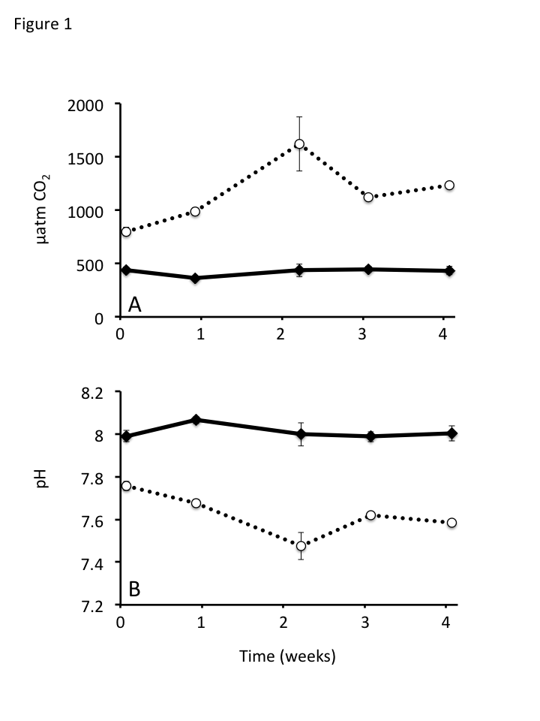

Figure 1. Summary of pH and concentration of dissolved CO2 (μatm) of the ambient (solid line) and elevated CO2 (dashed line) treated seawater. Concentrations of dissolved CO2 were calculated using total alkalinity, salinity, and pH measurements. Final pH measurements were adjusted to correspond to the 13°C treatment water. The plotted data are means ± standard deviation. Give overall mean and SD for each treatment.

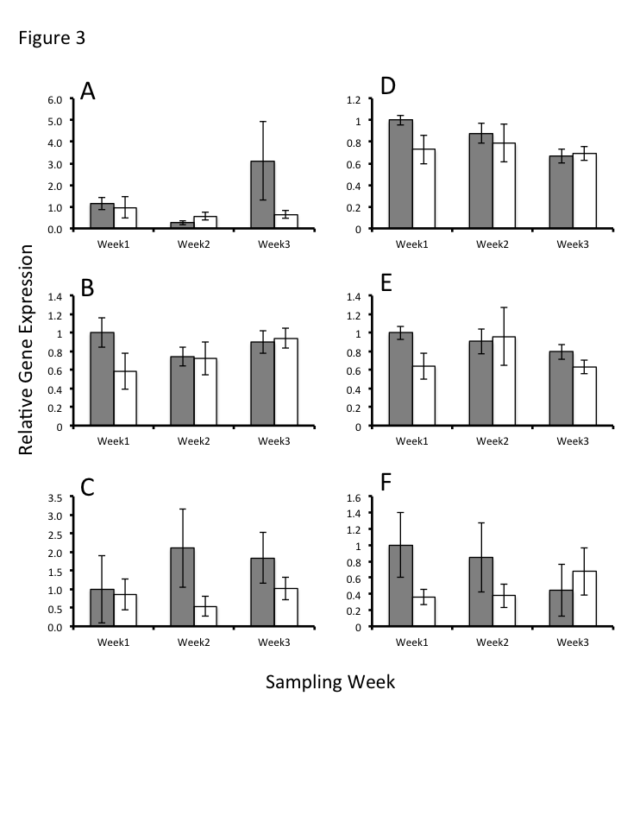

Figure 2. Quantification of transcript abundance in gill tissue of juvenile Manila clams exposed to ambient CO2 (grey bars) and elevated CO2 (white bars) (n= x for each treatment). Gill tissue samples were taken after 1, 2, and 3 weeks of exposure to CO2 treated water and analyzed for expression of perlucin (A), calmodulin (B), cathepsin L (C), ef2 (D), hsp90 (E), and GPx3 (F). All values are normalized to ef1-α and standardized to the average value of the corresponding ambient expression value from week one.



Figure 2. Percent survival of juvenile manila clams following a one hour exposure to a thermal stress at 39°C (A), or 38°C (B). Clams were acclimated for 3 weeks at either ambient (solid line) or elevated pCO2 (dashed line)conditions prior to thermal stress. After thermal stress, animals were returned to the corresponding treatment water and mortality was monitored daily for one week. A significant effect on survival was detected in the elevated pCO2 conditioned animals to a 40°C thermal stress.

|  |  |  |  |
| --- | --- | --- | --- |
| Gene Target | Oligo | Ruphibase ID | Primer sequence |
| Ef-1α | Fwd  Rev | ruditapes2_c4569 | ACGCTCCACTTGGACGTTTTGCT  TGTAGCCTTTTGGGCAGCTTTGGT |
| Hsp90 | Fwd  Rev | ruditapes_c1528 | TCTCCCTTGAAGAGCCAACAACCCA  TCATCATCACCTTCCAATGGGGGCA |
| Cathepsin | Fwd  Rev | ruditapes_lrc32628 | AGCCAAAGAACGGCCGATGTGA  TCCTACTGTTGCTACAGCGGCTTG |
| Calmodulin | Fwd  Rev | ruditapes_c670 | ACGACCAAGTGGACGAGATGTTGC  AGTACAGGCACTGGATGGTGCGTA |
| GPX3 | Fwd  Rev | ruditapes2_c3709 | ATTCTCGAGCGCTGGGGTAAAAGTG  TAGTTGTCGGCCGGCTCTTGCATT |
| Perlucin | Fwd  Rev | ruditapes_lrc29501 | GCAGACGTCGACAGGATGTCCAAT  ACAGTATGCCATAGCCTCCCACCA |
| EF2 | Fwd  Rev | ruditapes2_c46 | GACAGTGTTGTTGCTGGCTTCCAGT  TGTCCACCACCTCTGTGGATAGCA |

Table 1. List of primers sequences developed from the designated contig sequence in Ruphibase. Primers were developed using Primer 3 software.

|  |  |  |  |  |  |
| --- | --- | --- | --- | --- | --- |
| Ambient |  |  |  |  |  |
| TA | Salinity | pH | pCO2 | Ω Ca | Ω Ar |
| 2078.49 | 29.79 | 8.01 | 424.11 | 2.71 | 1.71 |
| (±13.71) | (±0.25) | (±0.04) | (±44.90) | (±0.24) | (±0.16) |
|  |  |  |  |  |  |
| Elevated |  |  |  |  |  |
| TA | Salinity | pH | pCO2 | Ω Ca | Ω Ar |
| 2085.14 | 29.92 | 7.63 | 1146.11 | 1.24 | 0.78 |
| (±13.37) | (±0.21) | (±0.10) | (±312.42) | (±0.26) | (±0.17) |

Table 2. Summary of water chemistry measurements from ambient and elevated CO2 treatments.(mean±SD) for the 28 days of the juvenile clam experiment. Total alkalinity (TA), salinity, and pH were measured directly using techniques described in the methods. Other water chemistry parameters were calculated using CO2calc software with TA, salinity, and pH as the three inputs..